SAMPLE LETTER TO SCHOOL – Use your School’s Letterhead

(Student’s name) is a student at (your School’s name) and is studying (language) in our program. We recently tested our students’ language skills are very proud and excited about the results. We are enclosing (Student’s name)’s test score results in hopes that they can be recognized and that their skills can be documented with a state Seal of Biliteracy. (Edit if your state uses another name for the program.) We understand that (your language) is not taught in your program, but believe that to support equity and greater language diversity, (Student’s name) should be included and celebrated. Below, we have provided information about the test given and the testing protocols appropriate to high stakes testing that were used. Please contact us with any questions you may have.

The (test name) test used is an internationally recognized test developed to measure the language proficiency of non-native speakers. The test is scored by professionally trained raters. The (test name) is a qualifying test for the international Global Seal of Biliteracy and (if applicable) is an approved test for the (State name) Seal of Biliteracy. (edit if your state uses a different program name). Any additional requirements or procedures provided by the test company were strictly followed.
This test was proctored by a trained adult unrelated to any test-taker following standard testing procedures.

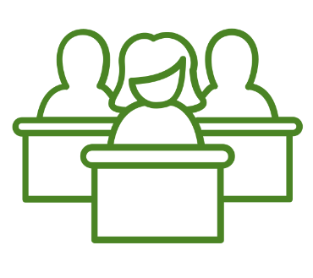
The identities of all students taking the test were verified. To ensure test security, students were seated at least 3’ apart and not facing any other test takers.

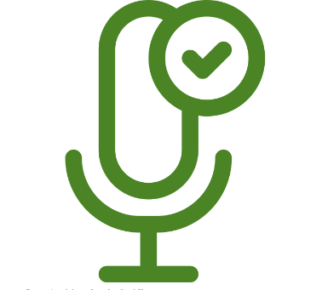
Students were provided with the necessary equipment required for test administration, including any listening or recording devices such as microphones and/or headsets.

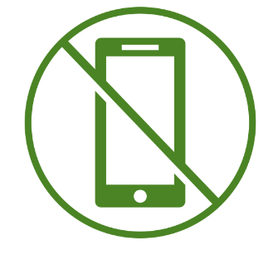
Test takers were not permitted to bring electronic devices or additional resources into the testing room or to take notes during the test. Any visuals such as posters that students might use as a language resource were removed or covered during testing.

